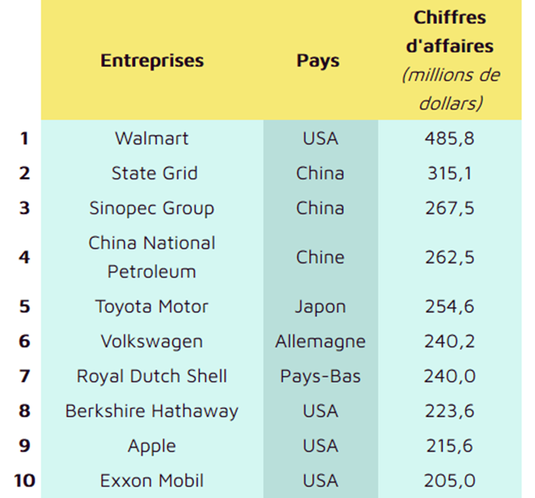

Poids des FTN :

|  |  |  |  |
| --- | --- | --- | --- |
|  | **Entreprises** | **Pays** | **Poids par rapport au PIB mondial en %** |
| **1** | Walmart | USA | =0.0062 |
| **2** | State Grid | China | =0.0040 |
| **3** | Sinopec Group | China | =0.0034 |
| **4** | China National Petroleum | China | =0.0033 |
| **5** | Toyota Motor | Japan | =0.0032 |
| **6** | Volkswagen | Germany | =0.0031 |
| **7** | Royal Dutch Shell | Netherlands | =0.0031 |
| **8** | Berkshire Hathaway | USA | =0.0028 |
| **9** | Apple | USA | =0.0027 |
| **10** | Exxon Mobil | USA | =0.0026 |

PIB mondial à prix constant 2016 : 77 328 milliards de dollars